2017

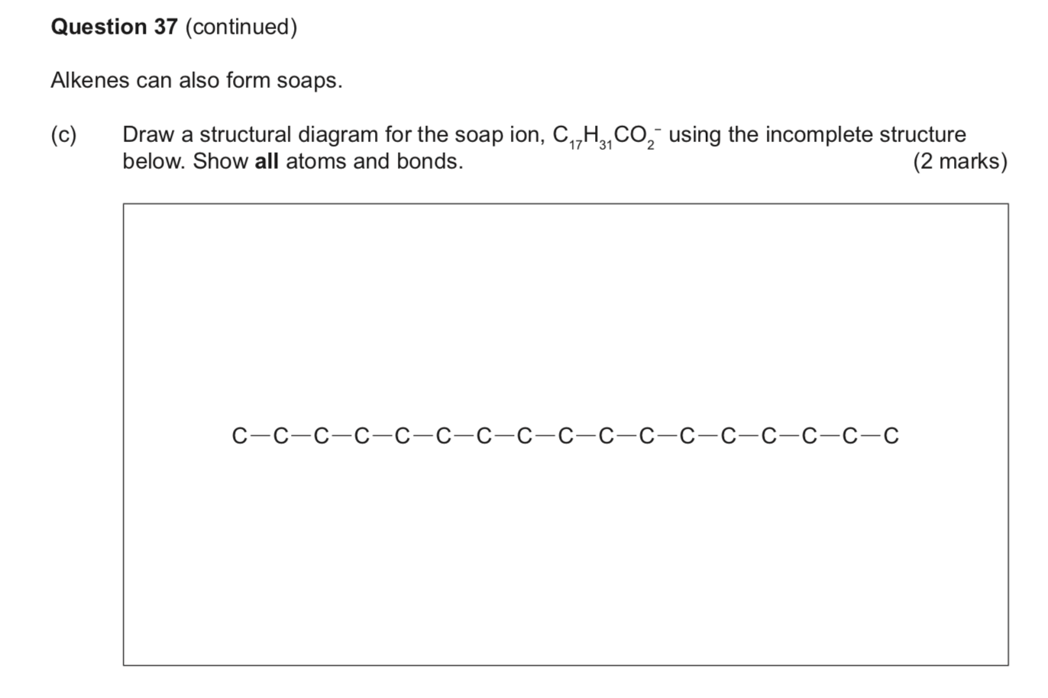

2019